Exploring the Impact of Code-Switching on Language
1 Maintenance and Identity Construction among Bilingual Immigrants
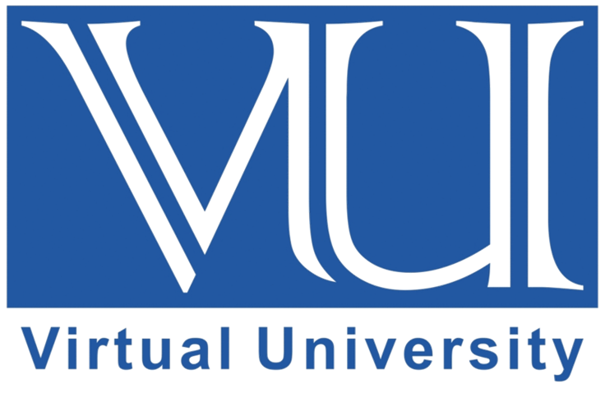
By
Student Name and ID
VIRTUAL UNIVERSITY OF PAKISTAN

Objectives of the Study:
.
Questionnaire
Dear students,
I am a student of BS English in the Virtual University of Pakistan and working on this research topic titled: “Exploring the Impact of Code-Switching on Language 1 Maintenance and Identity Construction among Bilingual Immigrants”. Kindly give your views without any bias and freely. Your opinions will only be used for research purposes. I would be thankful for your valuable opinions and time.
Gender
- Male
- Female
Table: 1: Questionnaires
Sr.  No. | Statement | Strongly Disagree | Disagree | Neutral | Agree | Strongly Agree
 | Bilingual individuals frequently switch between languages in different social settings.
 | Code-switching helps bilingual individuals feel connected to both their native and adopted cultures.
 | Bilingual individuals use code-switching to better express their thoughts and emotions.
 | Switching languages makes it easier for bilingual individuals to communicate with family and friends.
 | Bilingual individuals feel more comfortable using code-switching in informal settings than in formal ones.
 | Code-switching helps bilingual individuals maintain their native language skills.
 | Many people believe that code-switching is a natural part of being bilingual.
 | Bilingual individuals code-switch more frequently when they are with other bilingual individuals.
 | Using code-switching helps bilingual individuals feel a sense of belonging in different cultural contexts.
 | Many bilingual individuals find it challenging to avoid code-switching in conversations.
 | Code-switching influences how bilingual individuals identify themselves culturally.
 | Bilingual individuals use code-switching to fit in with different social groups.
 | Friends and family members of bilingual individuals also engage in code-switching.
 | Many bilingual individuals feel that code-switching enhances their bilingual abilities.
 | Code-switching helps bilingual individuals convey cultural nuances that might be lost if they stick to one language.
 | Some believe that code-switching can sometimes lead to misunderstandings.
 | Bilingual individuals notice changes in their identity based on the language they are using.
 | Code-switching allows bilingual individuals to maintain a strong connection with their cultural heritage.
 | Many believe that code-switching is an important skill in today's multicultural society.
 | Bilingual individuals often find themselves code-switching without consciously thinking about it.

